UAT Plan

for

[Titan Arm]

Index

[1. Scope 3](https://docs.google.com/document/d/1Dq-SJ4GeoBqFeKaQWZgQBKMCfFZN-aUruauvdOBvnS4/edit#heading=h.gjdgxs)

[1.1. Objectives and business requirements 3](https://docs.google.com/document/d/1Dq-SJ4GeoBqFeKaQWZgQBKMCfFZN-aUruauvdOBvnS4/edit#heading=h.30j0zll)

[1.2. Scope 3](https://docs.google.com/document/d/1Dq-SJ4GeoBqFeKaQWZgQBKMCfFZN-aUruauvdOBvnS4/edit#heading=h.1fob9te)

[2. Testing team 4](https://docs.google.com/document/d/1Dq-SJ4GeoBqFeKaQWZgQBKMCfFZN-aUruauvdOBvnS4/edit#heading=h.3znysh7)

[3. Environmental requirements 5](https://docs.google.com/document/d/1Dq-SJ4GeoBqFeKaQWZgQBKMCfFZN-aUruauvdOBvnS4/edit#heading=h.2et92p0)

[3.1. Hardware requirements 5](https://docs.google.com/document/d/1Dq-SJ4GeoBqFeKaQWZgQBKMCfFZN-aUruauvdOBvnS4/edit#heading=h.tyjcwt)

[4. Test Scripts 1](https://docs.google.com/document/d/1Dq-SJ4GeoBqFeKaQWZgQBKMCfFZN-aUruauvdOBvnS4/edit#heading=h.1t3h5sf)

Scope

1. **1** Objectives and business requirements

The Goal of this UAT is to ensure all features of the prophetic arm works as intended and can be used in real-world circumstances.

**1.2** Scope

*For this UAT test, we’d like to:*

* *Does the collision detection system identify solid objects*
* *Does the system detect the button being pressed*
* *Does the device lock correctly*

*For the UAT test, we are not testing:*

* *The connection between the arm and prosthetic*
* *The hook’s ability to hold onto rocks right.*
* *The button’s ability to stick.*

## 3 System Diagrams

In this section, paste any drawings or diagrams that help the UAT team understand the program being tested. With each drawing include a brief explanation of how the drawing represents the application or system being tested.

**Flow Chart**

**DIGITAL PICTORIAL DRAWING**

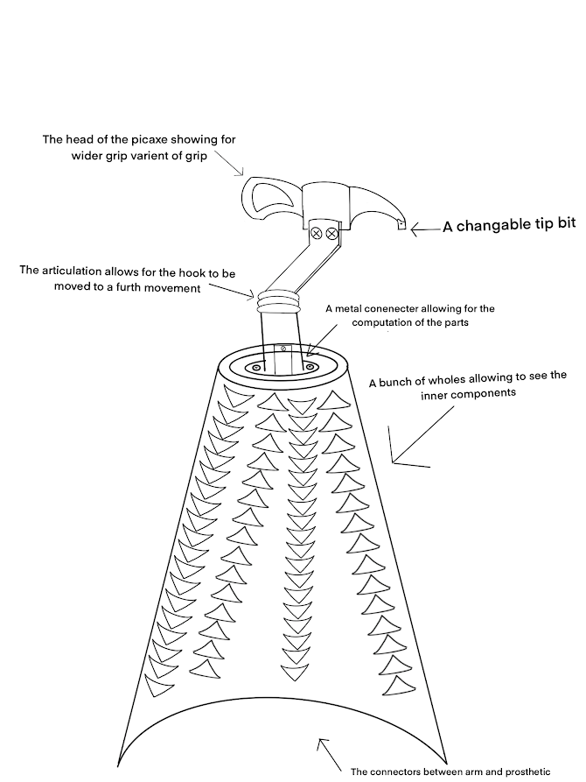

**Empathy Map for Aaron**

**Statement of intent**

My intend with the creation of the new rock-climbing prosthetic is to allow Aaron to be able to be able to rock climb again. The design was thought of through heavy inspiration of the Raptor Sky Hook and the SCALO Core77. The part of the design was taken with liberty allowing for me to create a whole new design which allows for 36-degree rotation as well as an extra 180-degree rotation which allows for different grabs, holds and pulls. The Design was to Aaron advice with changes being made through Aaron input.

**Communication with Patient**

**PSEUDOCODE**

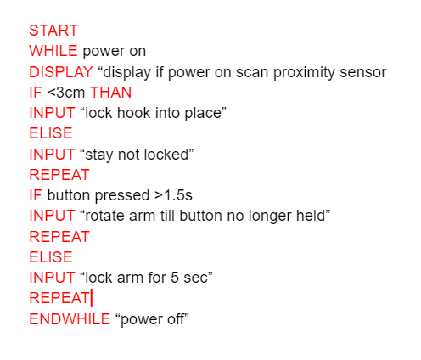

Testing team

|  |  |
| --- | --- |
| **Name** | **Responsibilities** |
| Alie Roberts | UAT Coordinator - talks to the patient and relays the information back to the team |
| Bob rose | Design test prosthetic and its ability to hold onto rocks |
| Scott Kendrick | Design test code as well and explains in further detail |
| Jaska Lewis | Design cables that have the ability to connect sensors to prosthetic |
| Drake fisher | Set up model for testing |

# Environmental requirements

## 4. Hardware requirements

1. *Motors*
2. *grip hook*
3. *A tip bit.*
4. *An articulation*
5. *A pic head*
6. *A wedge x2*
7. *Proximity Sensors*
8. *Button*

Test Scripts

|  |  |  |  |  |
| --- | --- | --- | --- | --- |
| **Test** | **Describe the feature being tested** | **Describe the user input or test data** | **Describe the pass criteria** |  |
| 1.1 | The proximity sensor ability to detect objects | 1. User starts by turning on prosthetic. 2. User puts prosthetic 2-3 centimetre from   rock 3. User than attempts to move hand by hand forcefully | 1. Device turns on. 2. Device recognizes rock. 3. Device locks into place 4. Device does not break excess force | Tester name: Bob Rose.   |  |  | | --- | --- | |  | PASS | |  | FAIL |   Observations: |
| 1.2 | The code’s ability to see how much pressure is needed for the button to activity | 1. User turns on prosthetic. 2. Measure how much pressure is needed. 3. Press button | 1. Device turns on. 2. Drive reads button. 3. Arm locks | Tester name: Scott Kendrick   |  |  | | --- | --- | |  | PASS | |  | FAIL |   Observations: |
| 1.3 | The arm’s ability to lock | 1. User turns on arm. 2. User presses button arm to lock arm. 3. User attempts to forcefully move arm | 1. Device turns on. 2. Button clicks. 3. Device responds. 4. Arm successfully locks | Tester name: Bob Rose.   |  |  | | --- | --- | |  | PASS | |  | FAIL |   Observations: |